Biomechanics – Cell and Tissue Bioengineering (CTBioE)

Clinical Lead (Prof Duncan Angus McGrouther)
Engineering Lead (Dr Wong Yoke Rung)

Quadrant supports offered by CTBioE
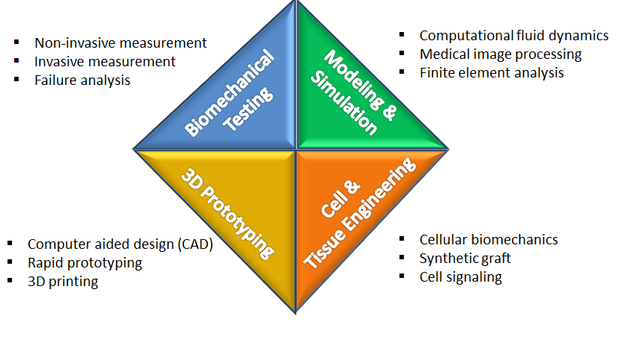

CTBioE is managing Biomechanics Lab located at Academia Level 1, houses state-of-art equipment and facilities to support various research and development activities as shown below.

Biomechanical Testing
Through close collaboration with clinicians and PIs from various departments (Hand Surgery,Orthopaedics, Plastic Surgery, Urology, Podiatry, Nursing Division, Occupational Therapy and etc) and institutions (Duke-NUS, NUS, NTU, SUTD and etc), CTBioE has developed comprehensive capability in biomechanics research specializing in static testing (3343, Instron Corp., Canton MA, USA), cyclic testing (ElectroPuls 1000, Instron Corp., Canton MA, USA), kinematics analysis (EM sensors;3D Guidance trakSTAR Electromagnetic 6DoF Tracking Solution; Ascension Technology Corporation, Northern Digital Inc, Shelburne, Vermont), force measurement (flexiforce sensors, Tekscan, MA, USA), liquid pressure measurement (USB6366, National Instruments, TX, USA), and etc. Data obtained is very valuable for the failure analysis and translational research which is essential requirements of surgical repairs and implant development.

3D prototyping
The lab houses essential hardware and software to support medtech device development. The 3D printer (uPrint Se Plus, Stratasys, UK) is capable to fabricate a 3D model for pre-surgical planning based on CT or MRI scans, device and jig customization. The 3D printer is fully supported by pre-processing model slicer (CatalystEX, Stratasys, UK) and CAD design modeler (Solidwork, Dassault Systemes Deutschland GmbH, Stuttgart, Germany).

Modeling and Simulation
The lab is equipped with advanced software such as Mimics (Materialise NV, Leuven, Belgium) for 3D model reconstruction of CT and MRI scanned images. Other software includes ANSYS (ANSYS Inc., Pennsylvania, USA) and MatLab (MathWorks inc, Natwick MA, USA) are also available for pursuing research in multiphysics with finite element analysis (FEA) and computational fluid simulation (CFD) and Artificial Intelligent (AI) modeling.

Cell and Tissue Engineering
To provide broad base support for the research within SGH, CTBioE is expanding his capability by acquiring a bi-axial mechanical tester (BISS 50N Planar biaxial system, Instron Corp., Canton MA, USA). The equipment is capable of maintaining a constant chamber temperature and is compact enough to fit onto a benchtop or a biosafety-cabinet. The BISS mechanical tester is suitable for soft tissues such as cartilages, which are commonly subjected to mechanical forces from multiple directions; or mechano-transduction related studies such as tissue grafting or cellular signaling; or employment of synthetic scaffolds for repair of bone, tendon and nerve through computational design, cell and tissue engineering and preclinical testing in animal studies.

Synergy and cohesion between the research peaks, groups and facilities
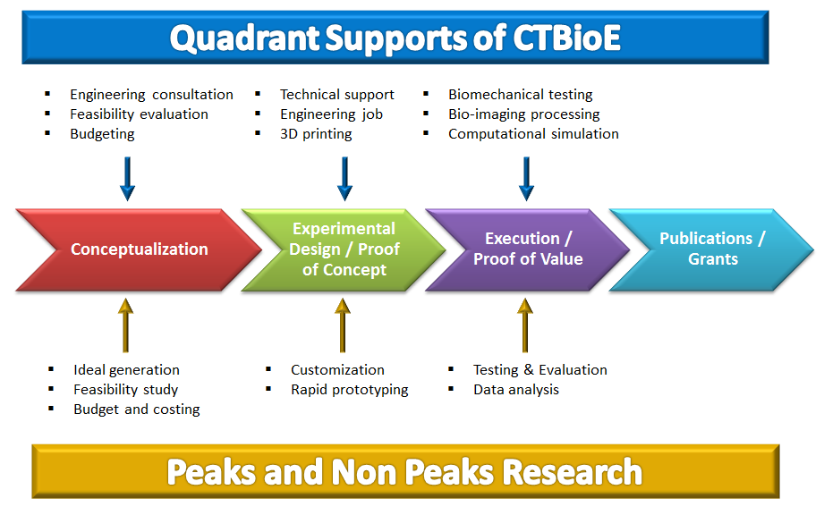

The quadrant supports developed by CTBioE enables various research initiated by Peaks and Non Peaks at different stages along the research roadmap. Some of the successful working examples are shown as below.

- Tipless urinary catheter (Peaks – Infection)
This medtech project was initiated by PI from Department of Urology to design and develop a novel urinary catheter for overcoming the clinical problems associated with the use of urinary catheters such as blockage, sediment, leakage (bypassing), bladder spasms, and recurrent bleeding from catheter cystitis. With the help and assistance provided by the quadrant supports, the project idea was conceptualized at the first stage for feasibility study, budgeting and costing for grant applications, technical consultation for experimental design; through second, third and fourth stage of 3D printing of prototypes and customization of testing jigs for various experimental investigation for product refinement and patent application. (This project has been funded by SGH - ACP Surgery Seed Fund, SRG Research Grant and SingHealth – Academic Medicine Grant).

- Investigation of osteoarthritis at wrist joint (Peaks – Aging)
This basic and translational study was a joint effort in collaboration with clinicians from Department of Hand and Reconstructive Microsurgery (HRM) and Occupational Therapy (OT). The end goal is to develop a predictive model for understanding the kinematics in related to development of osteoarthritis and eventually preventing the formation of osteoarthritis at wrist joint. Technical and engineering supports are provided in order to meet the intensive experiment and computation requirement throughout the research roadmap. (This project is funded by SingHealth – SingHealth Foundation Grant).

